**FlyAway**

**Online Ticket Booking**

**This document contains sections for:**

 Project overview

 Project's core concepts

 Flow of the Application

 Agile and Scrum: User Stories from the Project

 Demonstrating product capabilities, its presentation and user interactions.

 Pushing code on Github

 Conclusions

* The code for this project is hosted at:https://github.com/Prasannasyam/FlyAway.git

**Project Overview:**

1. Technologies used:

Frontend:HTML,JSP

Backend- JAVA Servlets

Database-MySQL

Application Server-Tomcat 8.5

2. Features:

 Book Flights - The user fills out flight information (date, source, destination, number of persons). A query is made to a remote database in order to retrieve associated flights, which are then displayed to the user. User can proceed to book the flight.

 Admin - A username and password are required to access the admin dashboard. After logging in, the administrator can change his password or can insert the new flights.

**Project Core concepts:**

 Language: Java (Eclipse IDE)  Concepts:

* + File Handling,
  + Exception Handling,
  + MYSQL-workbench,
  + KiRecursion,

. Sorting

Flow Control

# Flow chart of Application

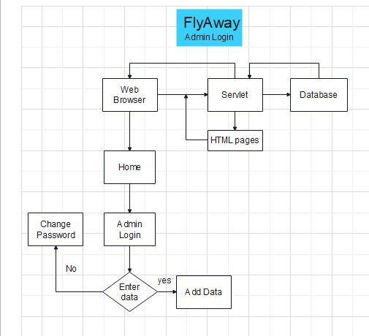

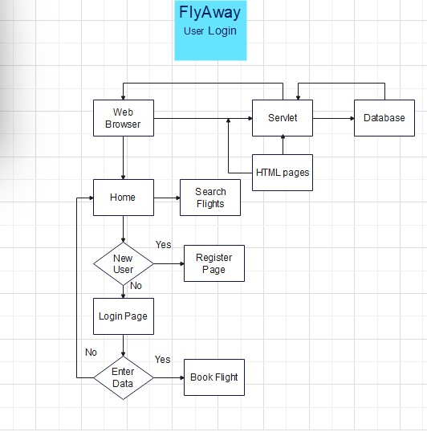

**A**gile and Scrum: Users Stories

The project will be finished in three sprints. The following tasks are expected to be performed throughout the sprint:

⇒ Creating the application's flow

⇒ Setting up a git repository to track changes as the project develops.

⇒ Writing a Java programme to meet the project's requirements.

⇒ Putting the Java software through its paces with various types of user input  Using GitHub to push code.

***Users Stories to be covered per sprint:***

# Sprint 1

1. As a user, I want to create account on website.
2. As a user, I can login and logout.

# Sprint 2

1. As a user, I want to search flight options available to me based on date, source and destination.
2. As an administrator, I can login to website.

# Sprint 3

1. As an administrator, I can add more flights.
2. As an administrator, I can change my password.

**Demonstrating product capabilities, its presentation and user interactions.**

The following sub-sections have been adjusted to showcase the project's aesthetic and user interactions in order to demonstrate the product's capabilities:

Home page:

Search for available Flights at homepage.

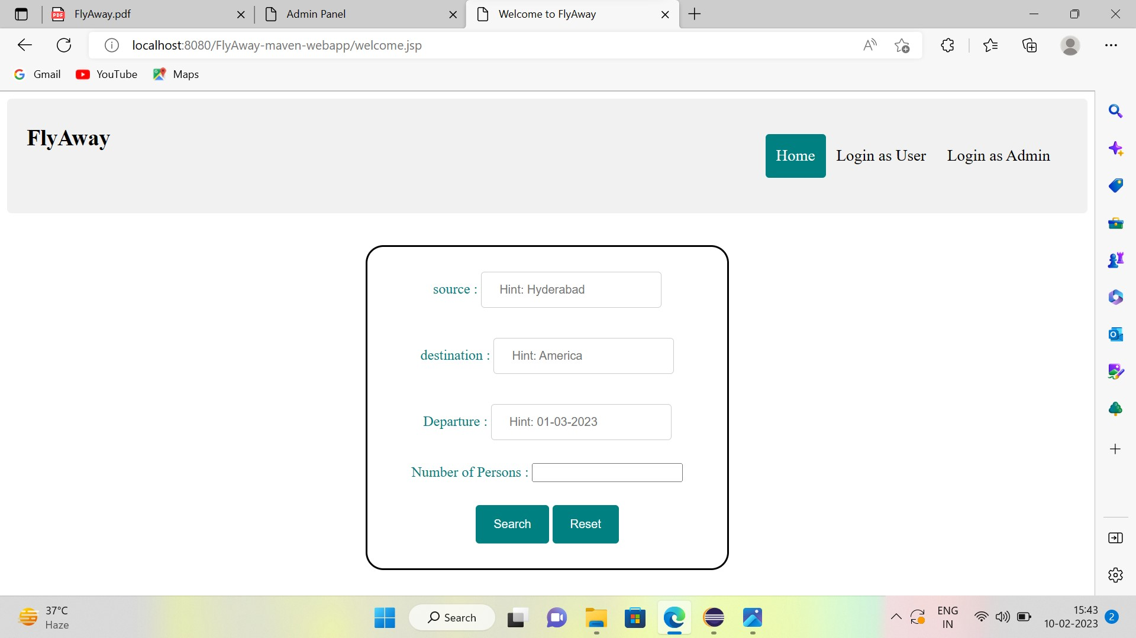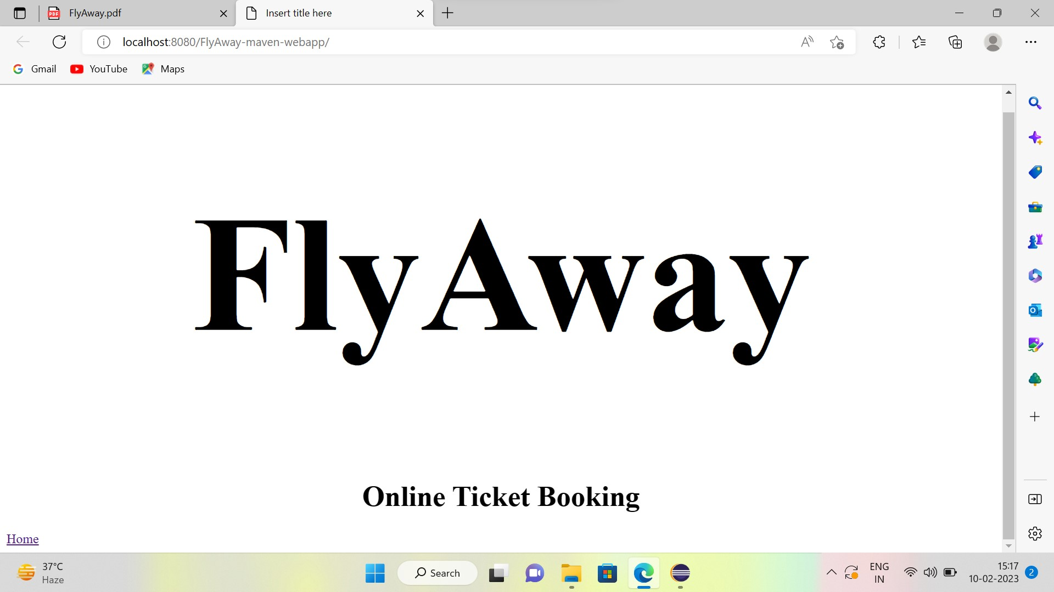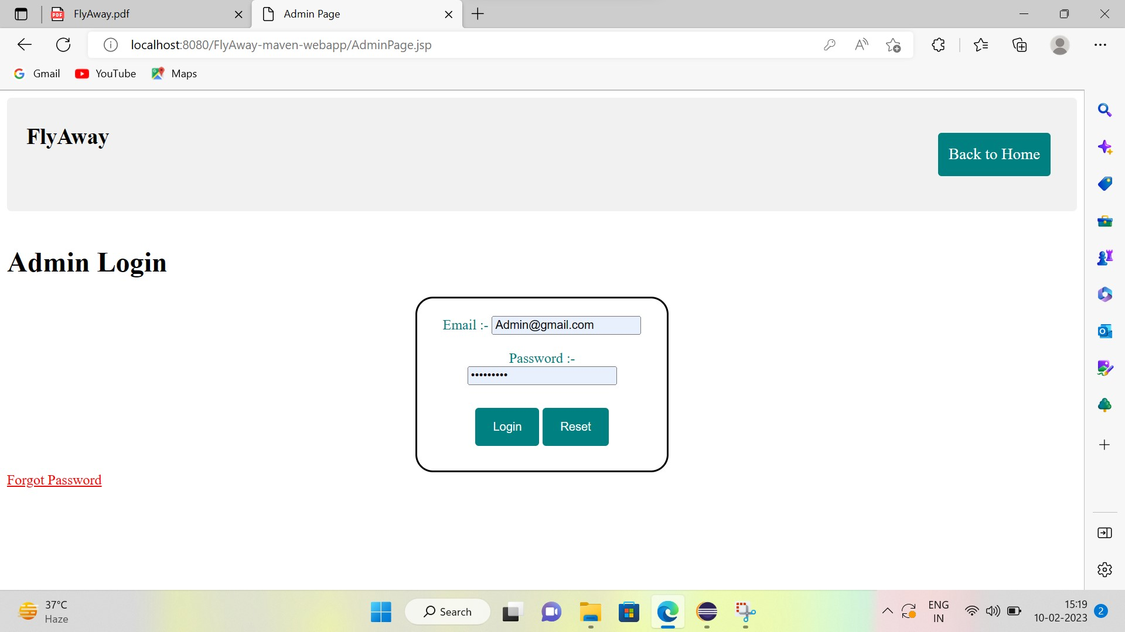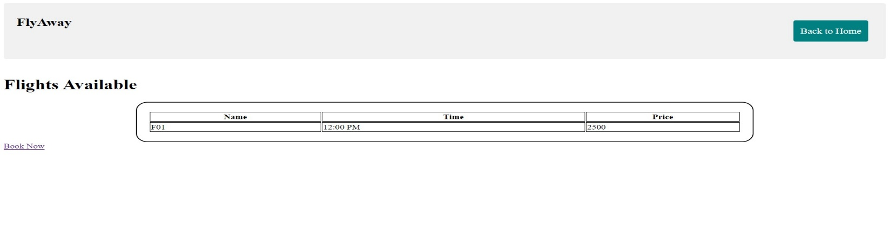 **Admin Login:**

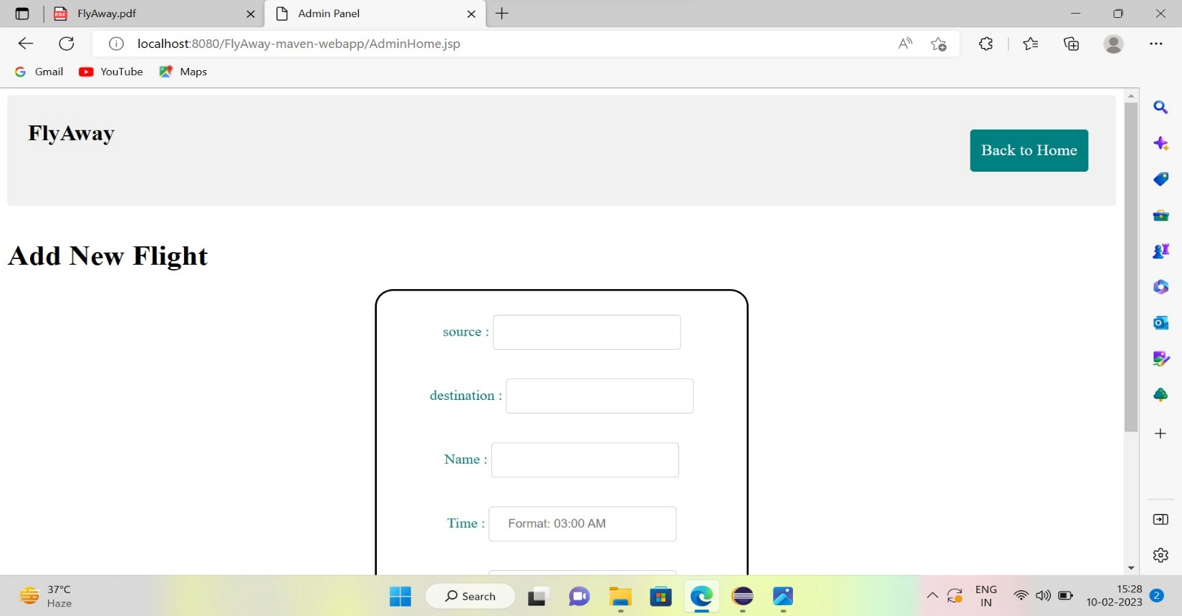Add New Flight as Admin:

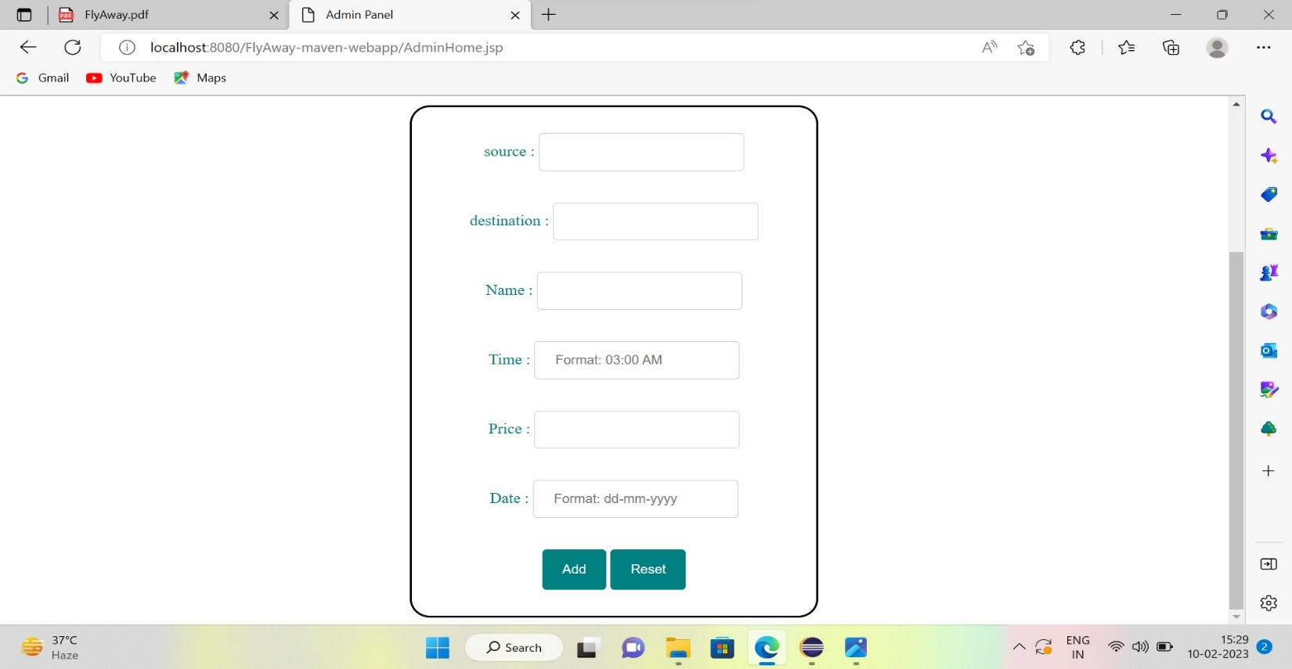

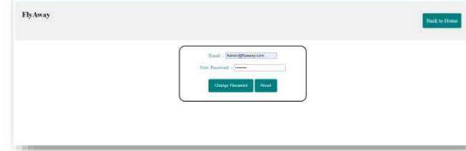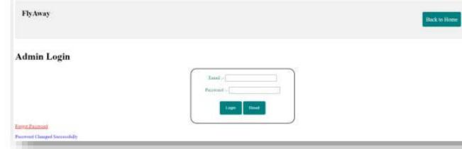**Create New Password as Admin:**

**Login or create account as user:**

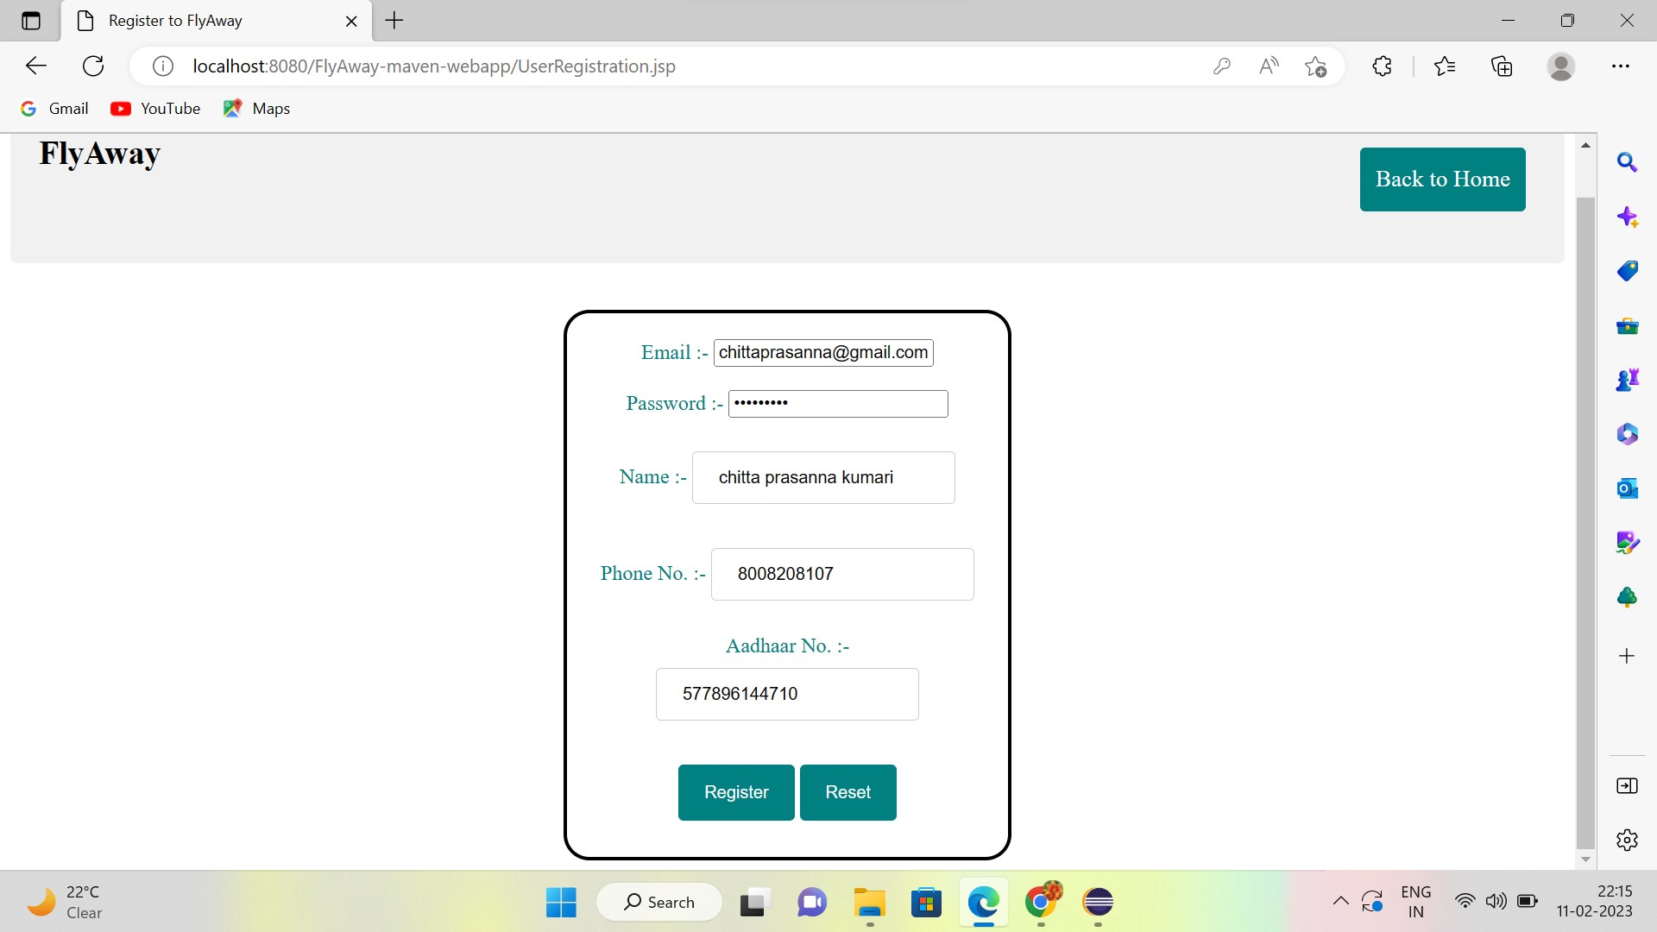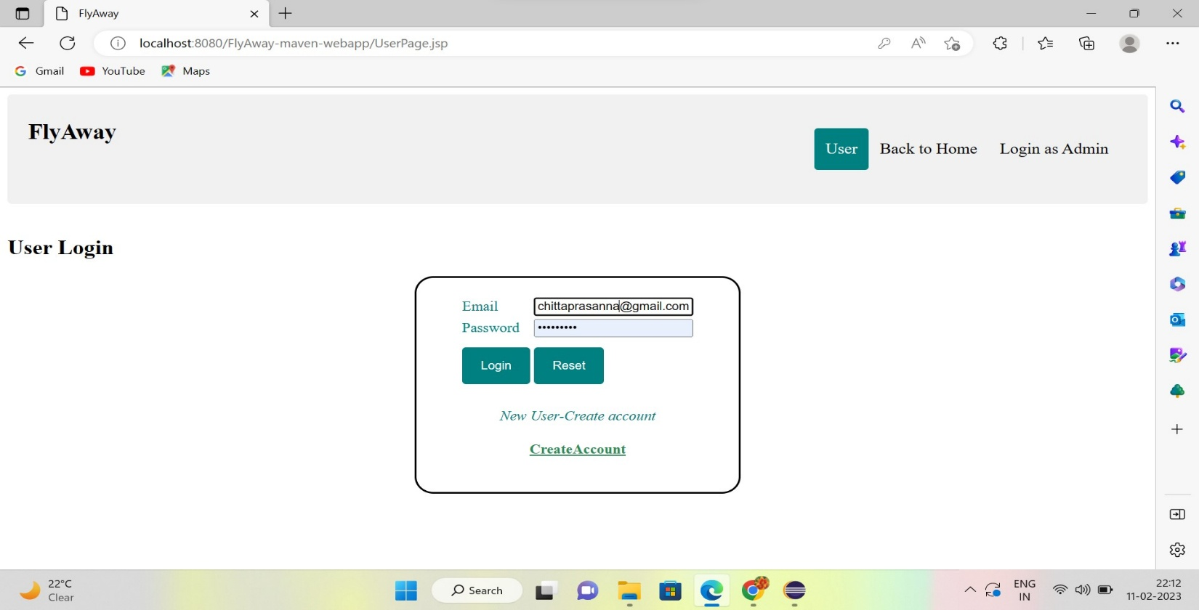

**Search and Book flight as user:**

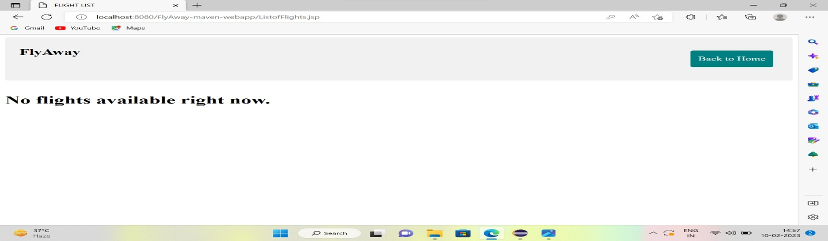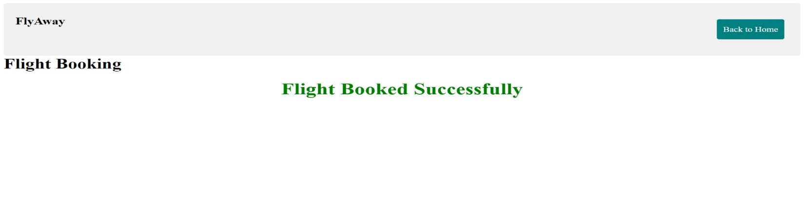

## Pushing the code to GitHub repository

* Open your command prompt and navigate to the folder where you have created your files.

*cd <folder path>*

* Initialize repository using the following command:

*git init*

* Add all the files to your git repository using the following command:

*git add .*

* Commit the changes using the following command:

*git commit . -m <commit message>*

* Push the files to the folder you initially created using the following command:

*git push -u origin master*

## Conclusions

An application with a sprint duration of three sprints has been developed in the programme. This application manages the *FlyAway* data. The user can create account and search or book a flight. The administrator can manipulate the flights data by logging in with an email ID and password. This application will be improved further by adding following features:

* Form/Input Validation
* Better CSS/Frontend Styles
* Modify available flights data
* Show previous flight bookings
* Ticket Payment